PYTHON PRACTICAL FILE
Q1. WAP to generate a list of n random integers within a specified range [a,b][a, b]. The program should then: a) Display the generated random numbers.
b) Identify and display the maximum and minimum numbers in the list.
c) Count and display the number of even and odd numbers in the list.
d) Calculate and display the average of all the numbers in the list.
Input
#(i)
import random
n=int(input("Enter the number of random numbers you have to generate: "))
a=int(input("Enter the starting range: "))
b=int(input("Enter the ending range: "))
def gen_ran_nos(n,a,b):
return [random.randint(a, b) for i in range(n)]
i=(gen_ran_nos(n,a,b))

#(ii)
maximum=max(i)
minimum=min(i)

#(iii)
t=0
s=0
for k in i:
if k%2==0:
t+=1
else:
s+=1

#(iv)
average = sum(i) / len(i)

#Display
print(i)
print("The maximum value from the list is",maximum)
print("The minimum value from the list is",minimum)
print("The number of odd numbers is",s)
print("The number of even numbers is",t)
print("The average of all the numbers is",average)
Output
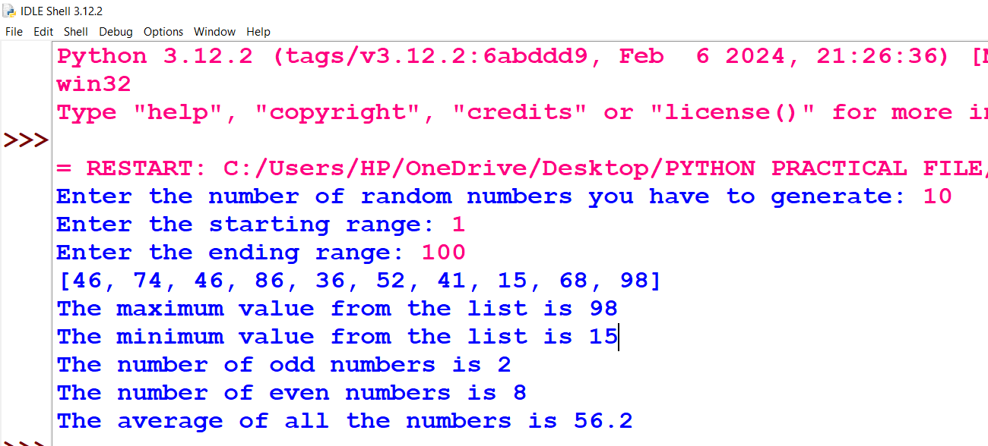
Q2. WAP to create a menu to perform the following operations: a) Find factorial of a number
b) Print prime numbers with in a range
c) Print Fibonacci series.
Input
def fact():
n=int(input("factorial of number: "))
fa=1
for i in range(1,n+1):
fa*=i
print("factorial is",fa)

def prime():
n=int(input("range of prime nos :"))
print('2')
for i in range(3,n+1):
f=0
for j in range(2,i):

if i%j==0:
f=1
continue
if f==0:
print(i)

def fab():
n=int(input("number of terms: "))
if n==1:
print('0')
elif n==2:
print("0")
print("1")

elif n>2:
f=0
s=1
print(f)
print(s)
i=0
while i<=n-2:
t=s+f
print(t)
f=s
s=t
i=i+1

print("1.FACTORIAL\n2.PRIME NUMBERS\n3.FIBONACCI SERIES")

cho=int(input("choice: "))

if cho==1:
fact()
elif cho==2:
prime()
elif cho==3:
fab()
else:
print("invalid entry")
Output
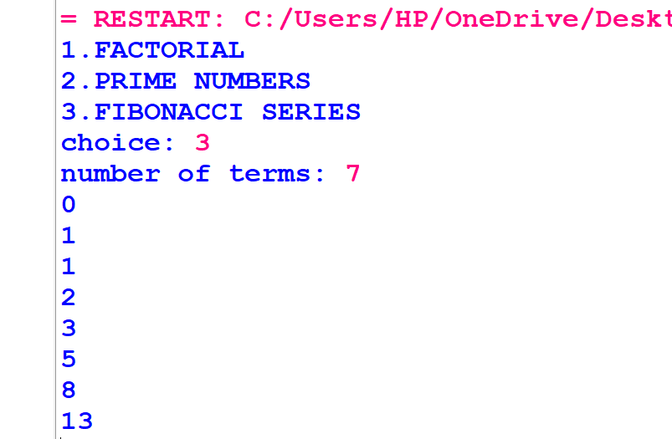
Q3.WAP to create a menu to perform the following operations on a user entered list
a) Print elements at even index.
b) Remove odd numbers from the list
c) Right Circular shift (by n) on the elements of the list
d) Double every even element
e) Display even elements at odd locations from the list.
f) Display the sum of elements ending with 3
g) Add element on a specific position given by user
h) Append element to the list
Input
#(i)
li=[]
a=int(input("NUMBER OF ELEMENTS IN THE LIST: "))
for i in range (a):
s=int(input("Enter element: "))
li.append(s)
print()
def one(li):
for k in range (len(li)):
if k%2==0:
print(li[k],end=" ")
print()
def two(li):
l=[]
for i in range(0,len(li)):
if li[i]%2==0:
l.append(li[i])
li=list(l)
print(li)

def three(li):
ni=int(input("No of shifts= "))
print("INITIAL LIST:",li)

while ni>0:
key=li[0]

for i in range (1,len(li)):
key,li[i]=li[i],key
li[0]=key
ni=ni-1
print("REQUIRED LIST:",li)

def four(li):
for i in range(len(li)):
if li[i]%2==0:

li[i]*=2
print(li)

def five(li):
n=len(li)
for i in range(n):
if i%2!=0:
if li[i]%2==0:
print(li[i])

def six(li):
sum=0
for i in range(len(li)):
if li[i]%10==3:
sum+=li[i]
print(sum)

def seven(li):
ide=int(input("index: "))
ele=int(input("element: "))
li.insert(ide,ele)
print(li)

def eight(li):
ele=int(input("element: "))
li.append(ele)
print(li)

print("1.PRINT ELEMENT AT EVEN INDEX\n2.REMOVE ODD NUMBERS FROM A LIST\n3.RIGHT CIRCULAR SHIFT ON LIST\n4.DOUBLR EVEN ELEMENT\n5.DISPLAY EVEN ELEMENTS AT ODD LOCATION\n6.DISPLAY SUM OF ELEMENTS ENDING WITH 3\n7.ADD ELEMENT AT LOCATION GIVEN BY USER\n8.APPEND ELEMENT TO LIST\n9.EXIT\n")
while True:
cho=int(input("enter choice: "))
if cho==1:
one(li)
elif cho==2:
two(li)
elif cho==3:
three(li)
elif cho==4:
four(li)
elif cho==5:
five(li)
elif cho==6:
six(li)
elif cho==7:
seven(li)
elif cho==8:
eight(li)
elif cho==9:
break
else:
print("INVALID CHOICE")
print()
Output
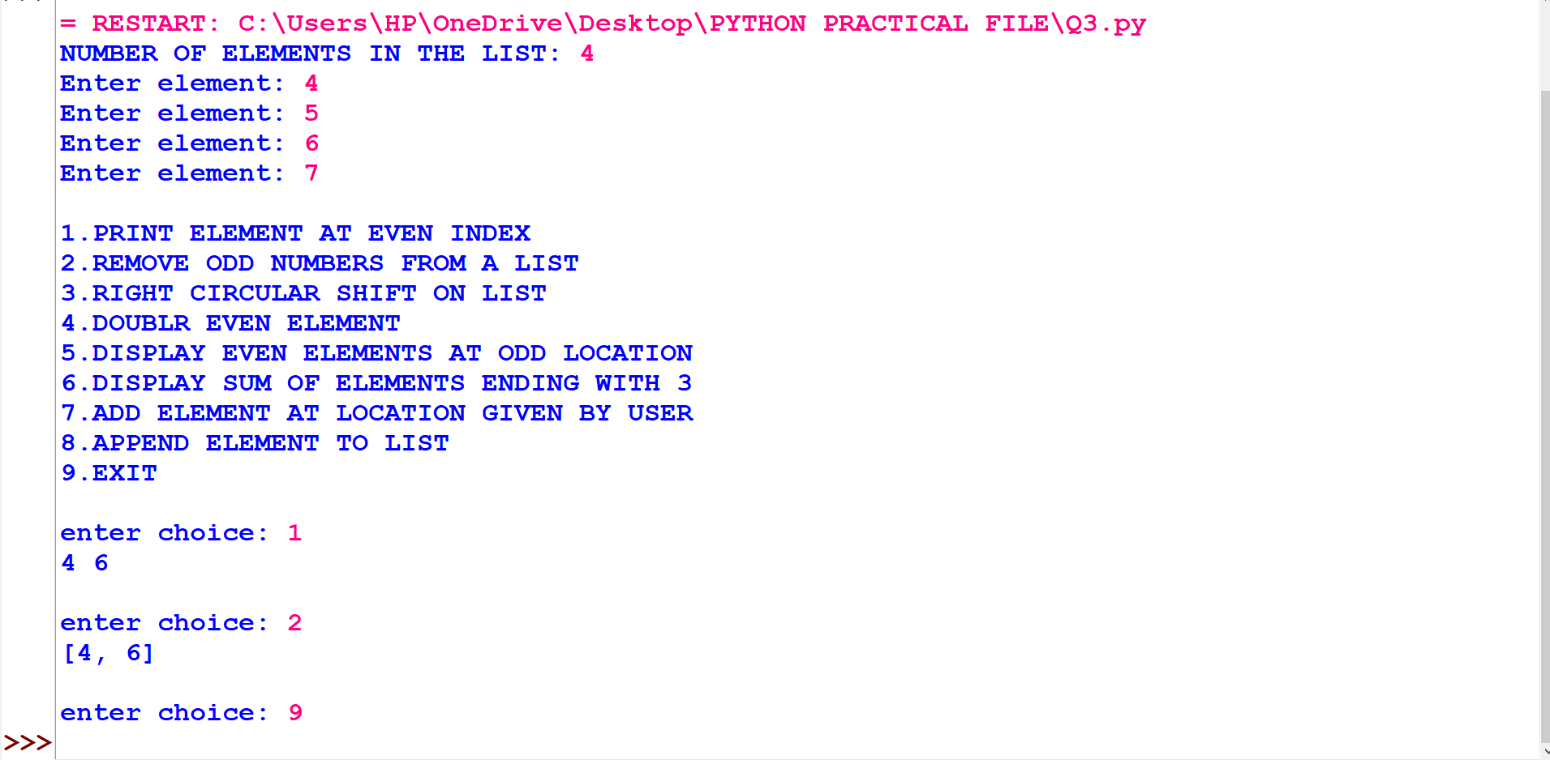
Q4. Write a program to shift the negative numbers to right and the positive numbers to left in a list entered by the user.
Input
def move(li):
li.sort(reverse=True)
li =eval(input("Enter a list: "))
move(li)
for i in li:
print(i , end = " ")
Output
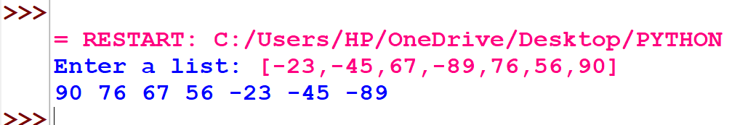

Q5. WAP to create a menu driven program to perform the following search operations:
a) Linear Search
b) Binary Search
Input
#(i)
def lin_search(li,ele):
n=len(li)
for i in range(n):
if li[i]==ele:
print("element found at index:",i)
break

else:
print("element not found")

#(ii)
def bin_search(li,ele):
n=len(li)
beg=0
end=n-1

while beg<=end:
mid=(beg+end)//2
if li[mid]==ele:
print("element found at index",mid)
break
elif li[mid]>ele:
end=mid-1
elif li[mid]<ele:
beg=beg+1

else:
print("element not found")

li=[]
nu=int(input("number of elements in list: "))
for j in range (nu):
a=int(input("enter element: "))
li.append(a)

print("1.LINEAR SEARCH\n2.BINARY SEARCH")
cho=int(input("your choice: "))
ele=int(input("element to be found: "))

if cho==1:
lin_search(li,ele)
elif cho==2:
bin_search(li,ele)
else:
print("invalid entry")

Output
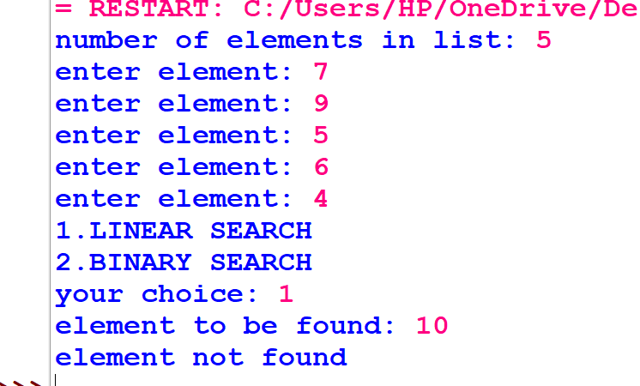
Q6.Write a program in Python with a function which accepts a list and exchanges the values of the first half side with the elements of the second half side elements.
Example: If a list of eight elements has initial content as 2,4,1,6,7,9,23,10 The function should rearrange the list as 7,9,23,10,2,4,1,6
Input
def half(my_list):
if len(my_list)%2 == 0:
start = 0
else:
start = 1

L = len(my_list)//2

for i in range(L):
temp = my_list[i]
my_list[i] = my_list[i+L+start]
my_list[i+L+start] = temp

my_list =eval(input("Enter a list: "))
half(my_list)
print(my_list)
Output
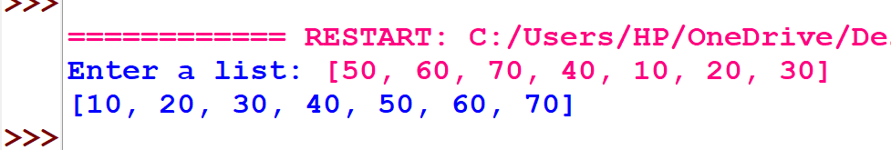

Q7. WAP to create a menu to check whether the string is palindrome or not and show statistics of characters in the user entered string (to counts the number of alphabets, digits, uppercase, lowercase, spaces and other characters).
Input
def Palindrome():
f=a[::-1]
if a==f:
print("The given string is a Palindrome")
else:
print("The given string is not a Palindrome")

def no_of_char():
alphabets=0
numbers=0
uppercase=0
lowercase=0
space=0
for i in a:
if i.islower():
lowercase+=1
elif i.isupper():
uppercase+=1
elif i.isdigit():
numbers+=1
if i.isalpha():
alphabets+=1

print("The number of uppercase letters:",uppercase)
print("The number of lowercase letters:",lowercase)
print("The number of digitcase letters:",numbers)
print("The number of alphabets letters:",alphabets)

print("1.PALINDROME\n2.STASTICS")
cho=int(input("your choice: "))
a=input("Enter a string: ")

if cho==1:
Palindrome()
elif cho==2:
no_of_char()
else:
print("invalid entry")

Output
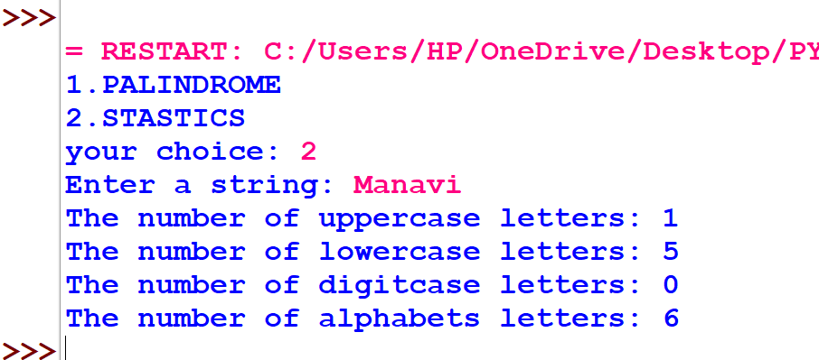
Q8. Write a menu driven program to perform the following operations:
a) Find the length of the string
b) Concatenate two strings
c) Reverse the string
d) Compare strings
e) Search the position of a substring in a string
Input
a=input("Enter a string: ")
def lenght_str():
f=len(a)
print("The lenght of the entered string is",f)

def conc_str():
b=input("Enter string to concatenate: ")
print("The concatenation of sting is",a+b)

def rev_str():
c=a[::-1]
print("The reverse of the entered str is",c)

def compare():
s1=input("string 1: ")
s2=input("string 2: ")
n1=len(s1)
n2=len(s2)
if n1>n2:
print("String 1 is longer than String 2")
elif n1==n2:
print("String 1 is of the same length as String 2")
else:
print("String 1 is shorter than String 2")

def search():
st=input("enter string: ")
sub=input("enter substring to be searched: ")
f=0

for i in range(len(st)):
for j in range(len(st)):
if st[i:j]==sub:
print("substring found at:",i)
f=1
break
if f==0:
print("substring not found")

print("1.LENGTH OF STRING\n2.CONCATENATE TWO STRINGS\n3.REVERSE STRING\n4.COMPARE STRINGS\n5.SEARCH POSITION OF SUBSTRING")
print()
ch=int(input("Enter choice: "))

if ch==1:
len_str()
elif ch==2:
conc_str()
elif ch==3:
rev_str()
elif ch==4:
compare()
elif ch==5:
search()
Output
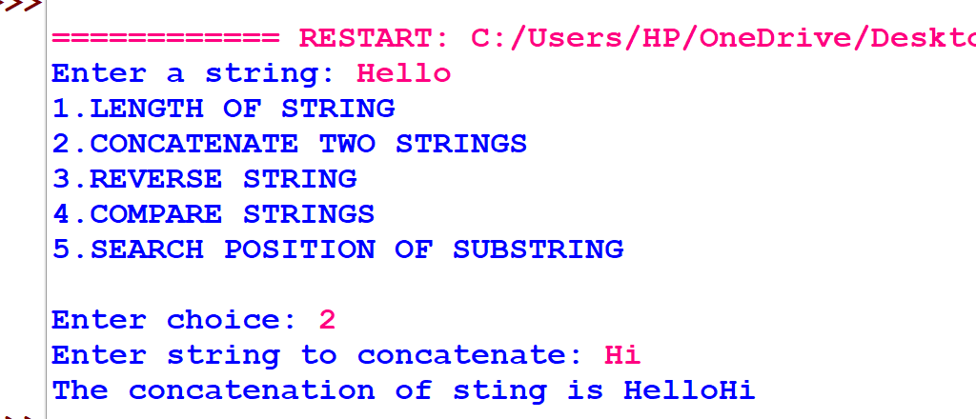
Q9.WAP to create a user defined tuple and count the occurrence of each element of the tuple using a dictionary.
Input
T=()
nu=int(input("number of elements in Tuple: "))
for j in range (nu):
a=int(input("enter element: "))
T=T+(a,)

dict={}
for k in T:
if k in dict:
dict[k]+=1
else:
dict[k]=1

print(dict)
Output
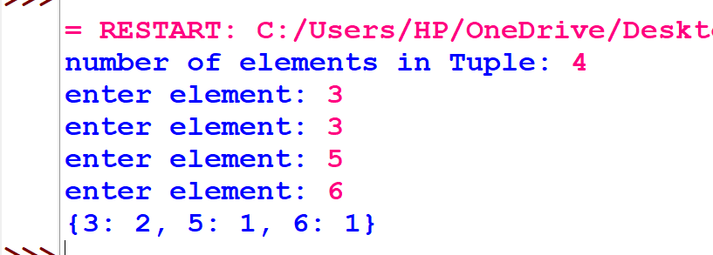
Q10.Write a program to input name of ‘n’ countries and their capital, it in a dictionary and create a menu to perform the following operations on it:
a) Add new entry
b) Display in tabular form
c) search and display for a particular country.
d) Update the Capital of a given country
e) Exit.
Input
def add(dictionary):
country=input("Enter the country you want to add: ")
capital=input("Enter the Capital of that country: ")
dictionary[country]=capital

def disp(dictionary):
for key in dictionary:
print(key,'|',dictionary[key])

def search(dictionary):
cou=input("Country to be searched: ")
for key in dictionary:
if key==cou:
print("Country found")
print(key,dictoinary[key])
break
else:
print("Country not found")

def update(dictionary):
cou=input("Country to be updated: ")
nc=input("New capital")
for key in dictionary:
if key==cou:
dictoinary[key]=nc

dictionary={}
n=int(input("No. of countries: "))

for i in range(n):
country=input("Country: ")
capital=input("Capital: ")
dictionary[country]=capital
print()
print("1.ADD ENTRY\n2.DISPLAY\n3.SEARCH AND DISPLAY COUNTRY\n4.UPDATE CAPITAL\n5.EXIT\n")

while True:
cho=int(input("Choice="))
if cho==1:
add(dictionary)
elif cho==2:
disp(dictionary)
elif cho==3:
search(dictionary)

elif cho==4:
update(dictionary)
elif cho==5:
break
print()
Output
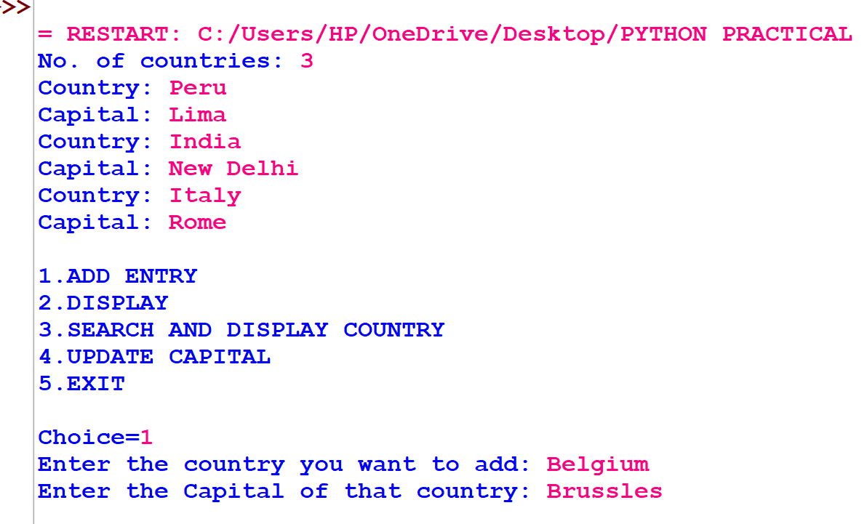
Q11. Write a program to input the name of a text file from the user and display:
a) Number of blanks present in the file.
b) Number of lines present in the file.
c) Number of capital alphabets present in the file.
d) Number of small alphabets present in the file.
e) Number of vowels present in the file.
f) Number of lines starting with capital alphabets
g) Number of words present in the file.
h) Number of digits present in the files.
i) Content of file in Upper case.
Input
def blank(f):
f1=open(f,'r')
x=0
s=f1.read()
for i in s:
if i==' ':
x+=1
print("no of blanks:",x)

def line(f):
f1=open(f,'r')
x=0
s=f1.readlines()
for i in s:
x+=1
print("no of lines:",x)

def capital(f):
f1=open(f,'r')
x=0
s=f1.read()
for i in s:
if i.isupper():
x+=1
print("no of capital alphabets:",x)

def small(f):
f1=open(f,'r')
x=0
s=f1.read()
for i in s:
if i.islower():
x+=1
print("no of small alphabets:",x)

def vowel(f):
f1=open(f,'r')
x=0
l=['a','e','i','o','u','A','E','I','O','U']
s=f1.read()
for i in s:
if i in l:
x+=1
print("no of vowels:",x)

def capital_line(f):
f1=open(f,'r')
x=0
for line in f1:
if line[0].isupper():
x+=1
print("no of capital lines:",x)

def word(f):
f1=open(f,'r')
x=0
for line in f1:
for word in line.split():
x+=1
print("no of words:",x)

def digit(f):
f1=open(f,'r')
x=0
s=f1.read()
for i in s:
if i.isdigit():
x+=1
print("no of digits:",x)

def upper(f):
f1=open(f,'r')
s=f1.read()
st=s.upper()
print(st)

def rev(f):
f1=open(f,'r')
s=f1.readline()
while s:
print(s[::-1])
s=f1.readline()

f=input("file name with extension: ")

print()
print("a) Number of blanks present in the file.\nb) Number of lines present in the file.\nc) Number of capital alphabets present in the file.")
print("d) Number of small alphabets present in the file.\ne) Number of vowels present in the file.\nf) Number of lines starting with capital alphabets")
print('''g) Number of words present in the file.\nh) Number of digits present in the files.\ni) Content of file in Upper case.\nj) Content in Reverse case\n''')
c='y'
while c=='y':

cho=int(input("choice (1/2/3..../10): "))

if cho==1:
blank(f)
elif cho==2:
line(f)
elif cho==3:
capital(f)
elif cho==4:
small(f)
elif cho==5:
vowel(f)
elif cho==6:
capital_line(f)
elif cho==7:
word(f)
elif cho==8:
digit(f)
elif cho==9:
upper(f)
elif cho==10:
rev(f)
else:
print('invalid entry')
c=input("y/n: ")
print()
Output
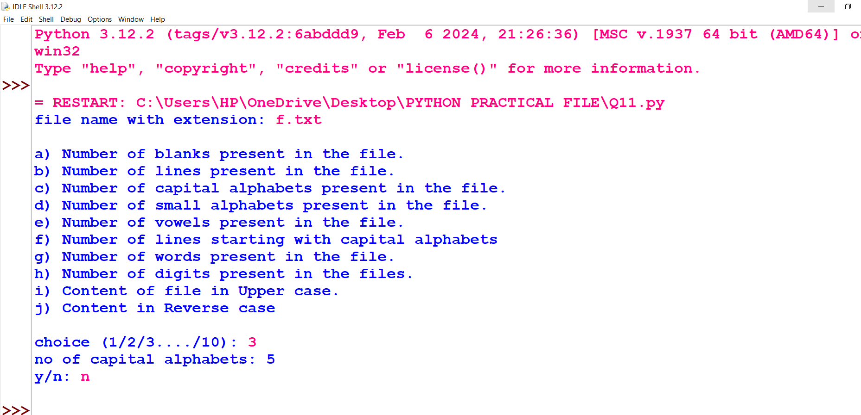
Q12.Write a program to show and count the number of words ‘Me’ and ‘My’ in a text file ‘STORY.TXT’.
Input
def displayMeMy():
num=0
f=open("story.txt",'r')
N=f.read()
M=N.split()
for i in M:
if i=="My" or i=="Me":
print(i)
num=num+1
f.close()
print("Count of Me/My if file",num)
displayMeMy()
Output
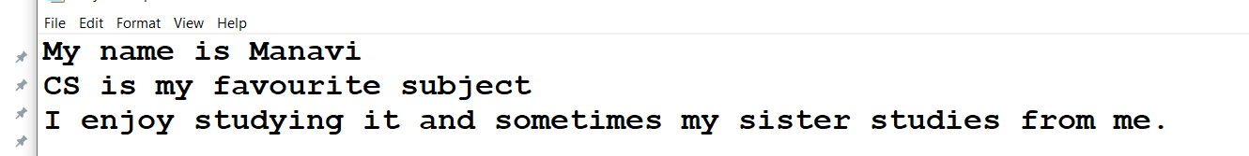

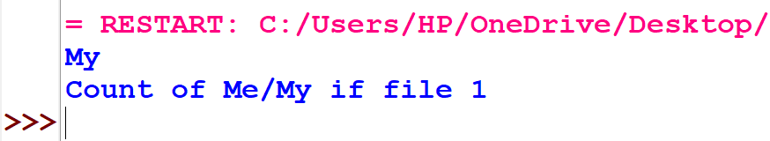
Q13. WAP to remove all the words that contain the character `a' in a file and write it to another file
Input
fo=open('file1.txt','r')
fi=open('file2.txt','w')
l=fo.readlines()
for i in l:
if 'a' in i:
i=i.replace('a','')
fi.write(i)
fi.close()
fo.close()
Output
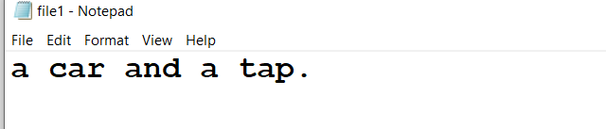
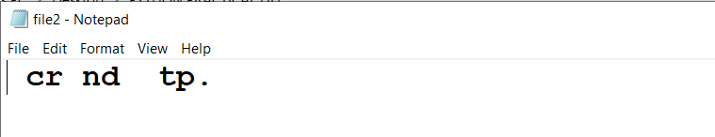
Q14. WAP that reads a text file (name to be provided by the user), remove all the lines that contain the character 'a' in a file and write it to another file
Input
fo=open("hp.txt","w")
fo.write("Harry Potter")
fo.write("There is a difference in all harry potter books\nWe can see it as harry grows\nthe books were written by J.K rowling ")
fo.close()

fo=open('hp.txt','r')
fi=open('writehp.txt','w')
l=fo.readlines()
for i in l:
if 'a' in i:
i=i.replace('a','')
fi.write(i)
fi.close()
fo.close()
Output
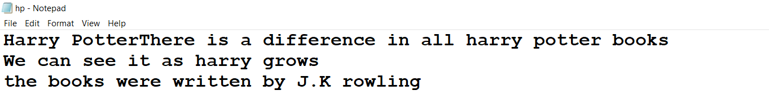

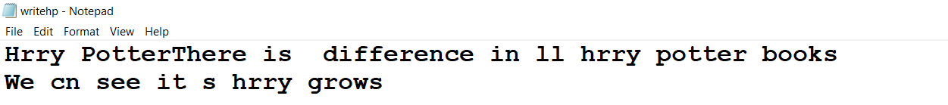
Q15.Write a program to read data from a text file DATA.TXT, and display word which have maximum/minimum characters.
Input
with open('data.txt', 'r') as file:
words = file.read().split()
max_len = len(max(words, key=len))
min_len = len(min(words, key=len))
for word in words:
if len(word) == max_len:
print('max:',word)
if len(word) == min_len:
print('min:',word)
Output
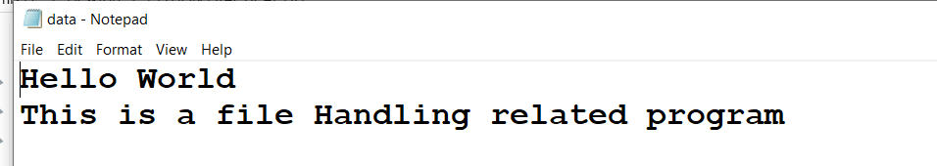
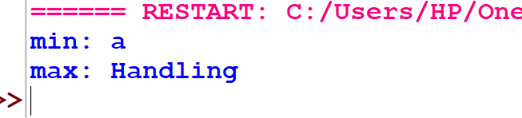
Q16. WAP to create the following menu to perform operations on file Book.dat (details of the book- Bookno, Bookname, Author, Price)
a) Add Record
b) Update Price
c) Exit
Input
import pickle

#(i)
def add_record(filename):
with open(filename, 'ab') as file:
book_no = int(input("Enter Book Number: "))
book_name = input("Enter Book Name: ")
author = input("Enter Author's Name: ")
price = float(input("Enter Price: "))
record = {'Bookno': book_no, 'Bookname': book_name, 'Author': author, 'Price': price}
pickle.dump(record, file)
print("Record added successfully!")

#(ii)
def update_price(filename):
updated = False
temp_records = []

with open(filename, 'rb') as file:
try:
while True:
record = pickle.load(file)
if record['Bookno'] == int(input("Enter Book Number to Update Price: ")):
record['Price'] = float(input("Enter New Price: "))
print("Price updated successfully!")
updated = True
temp_records.append(record)
except EOFError:
pass
#(iii)
with open(filename, 'wb') as file:
for record in temp_records:
pickle.dump(record, file)

if not updated:
print("Book number not found!")

# Main menu
filename = 'Book.dat'

while True:
print("\n--- Menu ---")
print("a) Add Record")
print("b) Update Price")
print("c) Exit")

choice = input("Enter your choice: ").lower()

if choice == 'a':
add_record(filename)
elif choice == 'b':
update_price(filename)
elif choice == 'c':
print("Exiting the program. Goodbye!")
break
else:
print("Invalid choice! Please try again.")
Output
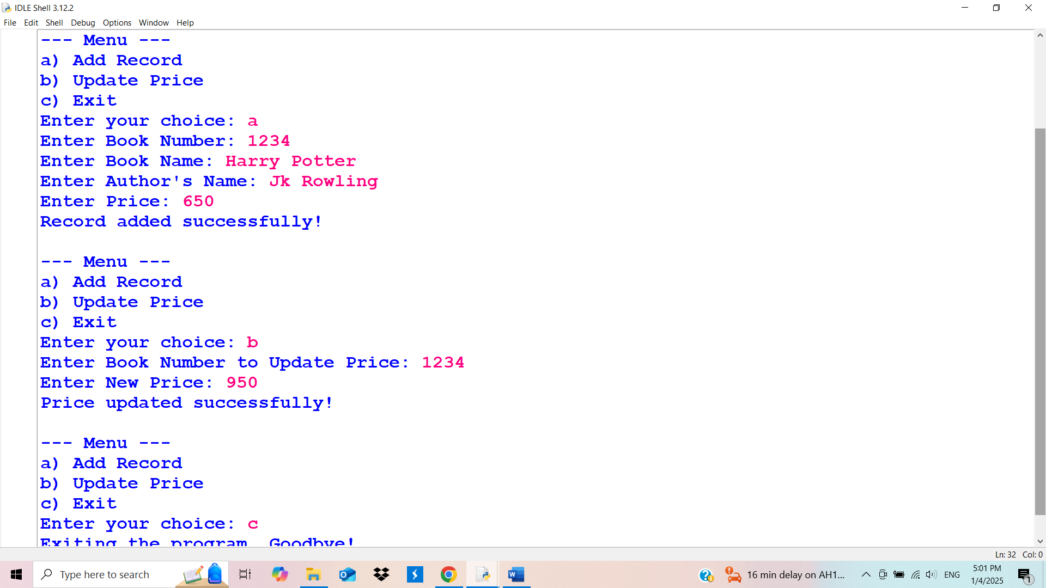
Q17. WAP to maintain a record of sports(name, no, fees) in a file(binary) and provide the user with options to add, search and delete record from file.
Input
import pickle
def add():
f=open("sports.dat","ab")
name=input("enter name: ")
no=int(input("enter phone no: "))
fee=int(input("enter fee: "))
dic={'name':name,'phno':no,'fee':fee}
pickle.dump(dic,f)
f.close()

def search():
f=open("sports.dat","rb")
na=input("enter name: ")
e=0
try :
while True:
s=pickle.load(f)
if s['name']==na:
e=1
print(s)
except EOFError:
f.close()
if e==0:
print("NO SUCH RECORD FOUND")

def delete():
f1=open("sports.dat","rb")
li=[]
de=input("enter name to delete record: ")
try :
while True:
s=pickle.load(f1)
li.append(s)

except EOFError:
f1.close()

f=open("sports.dat","w+b")
for a in li:
if a['name']!=de:
pickle.dump(a,f)
f.close()
def disp():
f=open("sports.dat","rb")

try :
while True:
s=pickle.load(f)
print(s)
except EOFError:
f.close()

print("1.SEARCH RECORD\n2.APPEND NEW RECORD\n3.DELETE RECORD\n4.DISPLAY RECORDS\n5.EXIT")
while True:

cho=int(input("choice= "))
if cho==2:
add()
elif cho==1:
search()
elif cho==3:
delete()
elif cho==4:
disp()
elif cho==5:
print("EXITED SUCCESSFULLY")
break
else:
print("INVALID ENTRY")
print()
Output
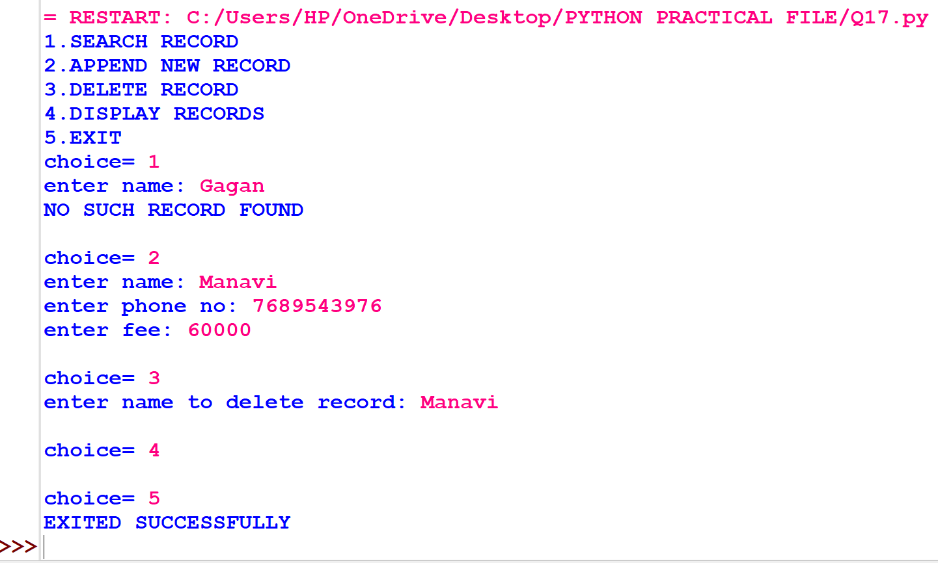
Create a menu-driven program to manage a CSV file sports.csv with the structure:
➢ sport_id: Integer (sport ID).
➢ competition: String (competition name).
➢ prize_won: String ("Gold", "Silver", "Bronze"). The program should include:
• Add Student Detail: Add a new record to the file.
• Count Gold Medals: Display unique competitions where "Gold" medals were won
Input
import csv

def Add_detail(filename):
with open(filename, 'a', newline='') as file:
writer = csv.writer(file)
print("Enter the details of the student:")
sport_id = int(input("Sport ID: "))
competition = input("Competition Name: ")
prize_won = input("Prize Won (Gold/Silver/Bronze): ")

writer.writerow([sport_id, competition, prize_won])
print("Details added successfully!")

def Count_Medal(filename):
with open(filename, 'r') as file:
reader = csv.reader(file)
header = next(reader)
gold_competitions = []

for row in reader:
if row[2].strip().lower() == 'gold':
competition = row[1]
if competition not in gold_competitions:
gold_competitions.append(competition)

print("Competitions where students won Gold medals:")
for competition in gold_competitions:
print(competition)

filename = 'sports.csv'

while True:
print("\n--- Menu ---")
print("1. Add Student Detail")
print("2. Display Competitions with Gold Medals")
print("3. Exit")

choice = int(input("Enter your choice: "))

if choice == 1:
Add_detail(filename)
elif choice == 2:
Count_Medal(filename)
elif choice == 3:
print("Exiting the program. Goodbye!")
break
else:
print("Invalid choice! Please try again.")
Output
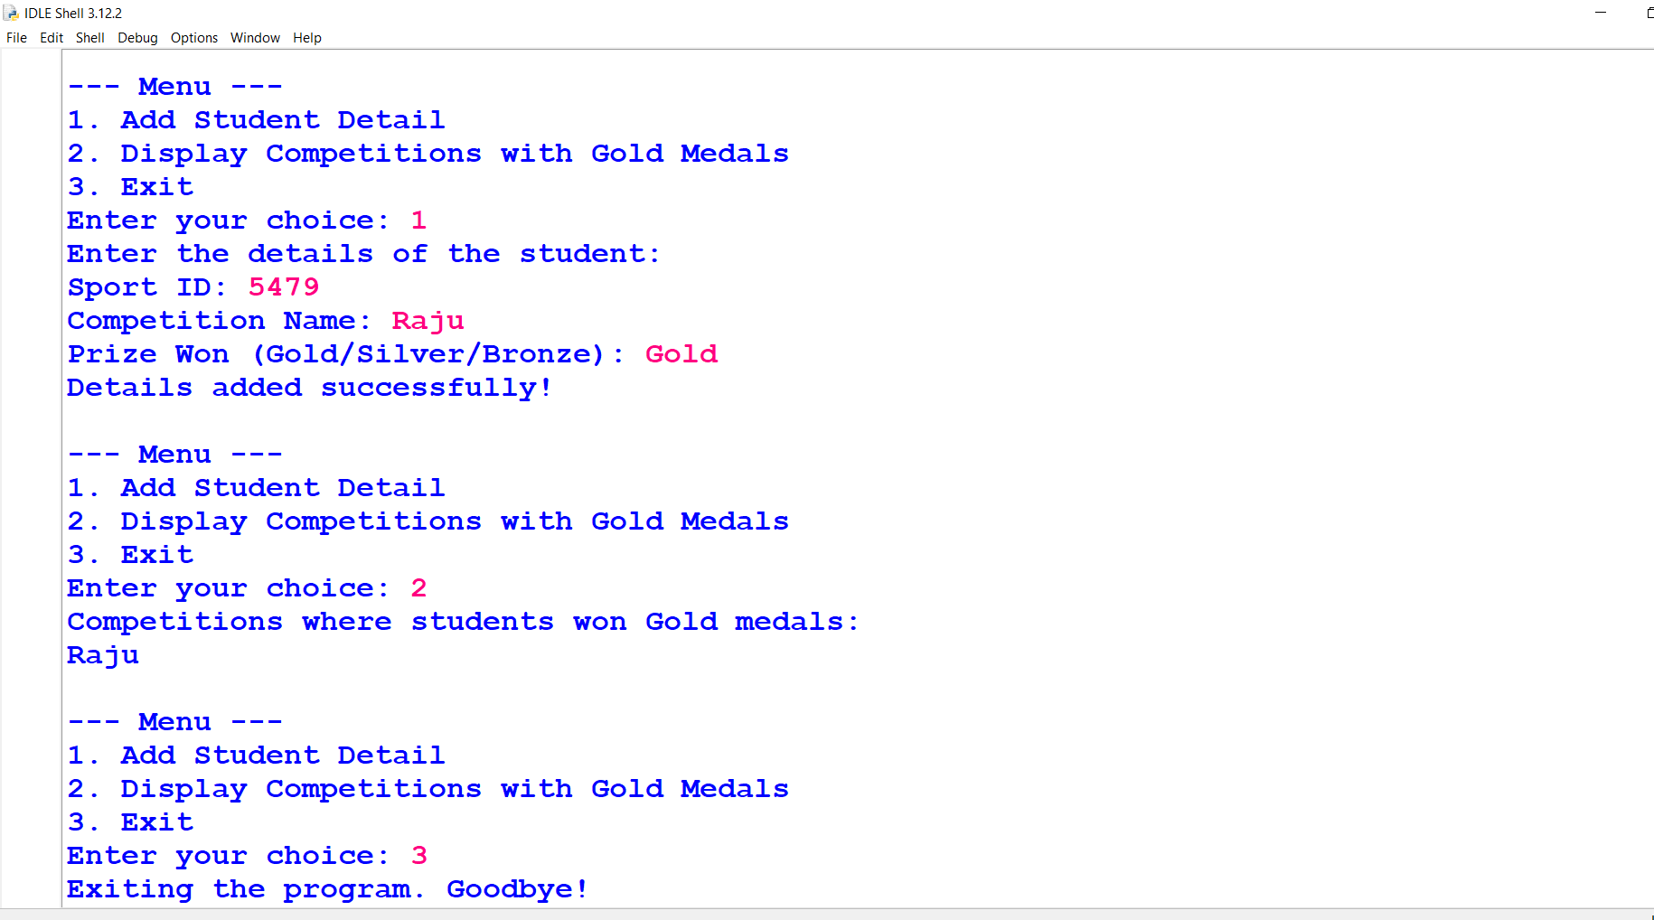
Q19. WAP to create a menu driven program to maintain a record of the students (Ano, Name, Percentage) in a CSV files
a) Append record in CSV
b) Search using Ano
c) Display the records.
d) Exit
Input
import csv
def add():
f=open("student.csv",'a')
re=csv.writer(f)
ano=int(input("enter ano: "))
name=input("name: ")
pc=int(input("enter percentage: "))
li=[ano,name,pc]
re.writerow(li)
f.close()
print("RECORD ADDED SUCCESSFULLY")
def search():
f=open("student.csv",'r',newline='\n')
an=int(input("enter ano to be searched: "))
re=csv.reader(f)
for i in re:
if i[0]==str(an):
print(i)
def disp():
f=open("student.csv",'r',newline='\n')
re=csv.reader(f)
print("[ANO , NAME , PERCENTAGE]")
for i in re:
print(i)
f.close()

print("1.APPEND RECORD\n2.SEARCH RECORD\n3.DISPLAY RECORD\n4.EXIT\n")
while True:
cho=int(input("choice: "))
if cho==1:
add()
elif cho==2:
search()
elif cho==3:
disp()
elif cho==4:
break
else:
print("INVALID CHOICE")
print()

Output
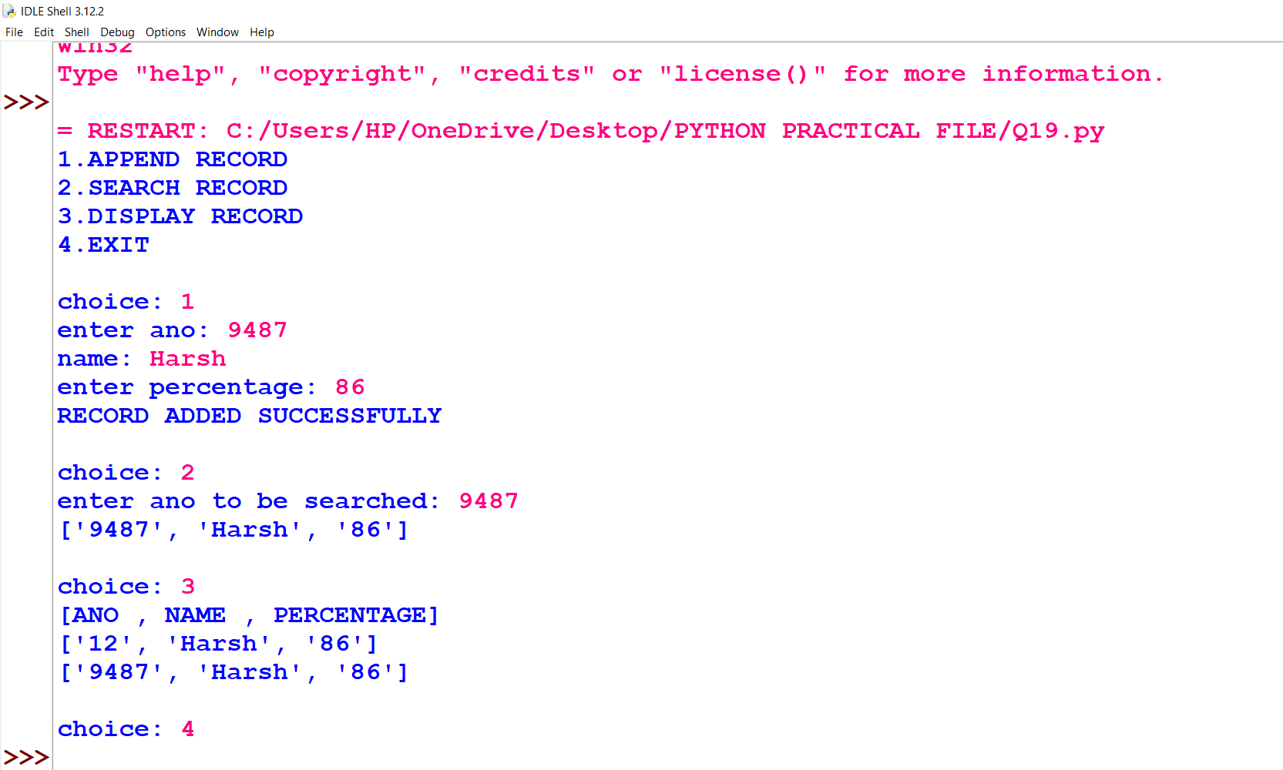
Q20. WAP to implement a stack using a list data-structure. Create a menu with the following operations for the same.
a) Pop
b) Push
c) Exit
Input
#stack implementation
def isEmpty(stk):
if stk==[]:
return True
else:
return False
def Push(stk,item):
stk.append(item)
top=len(stk)-1
def Pop(stk):
if isEmpty(stk):
return "Underflow"
else:
item=stk.pop()
if len(stk)==0:
top=None
else:
top=len(stk)-1
return item
#main
stack=[]
top=None
while True:
print("stack operations")
print("1.Push")
print("2.POP")
print("3.Display")
print("4.exit")
ch=int(input("enter your choice:"))
if ch==1:
item=int(input("enter item:"))
Push(stack,item)
print(stack)
elif ch==2:
item=Pop(stack)
if item=="Underflow":
print("underflow!stack is empty")
else:
print("popped item is",item)
print(stack)
elif ch==3:
print(stack)
elif ch==4:
break
else:
print("invalid choice!")
Output
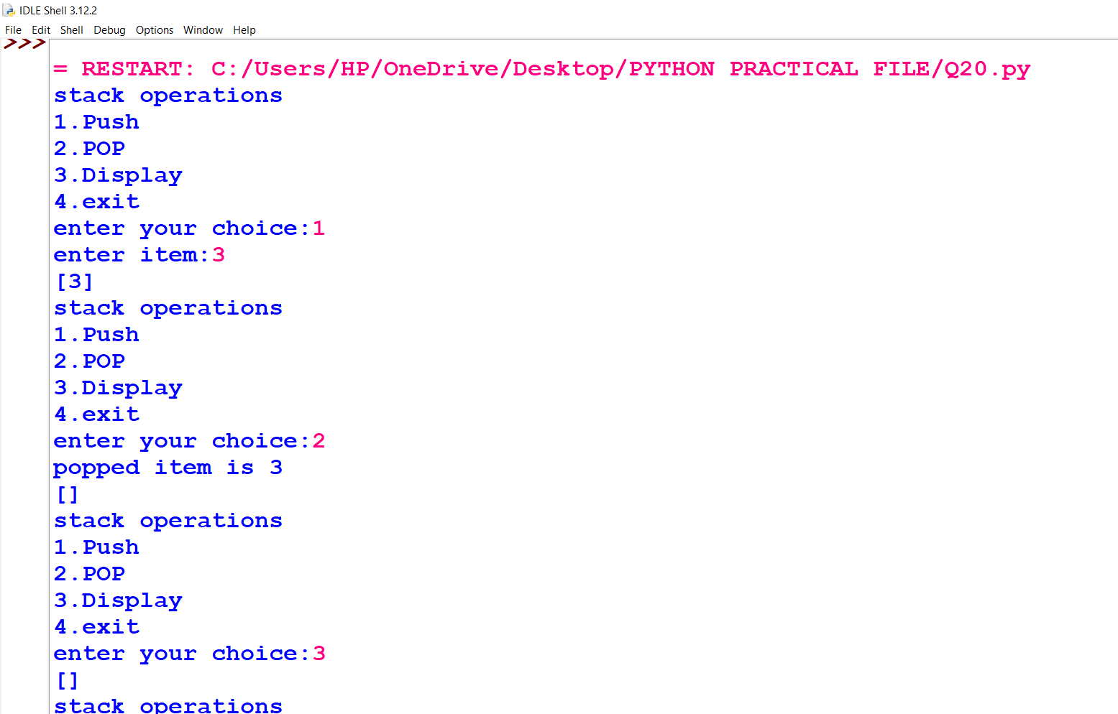
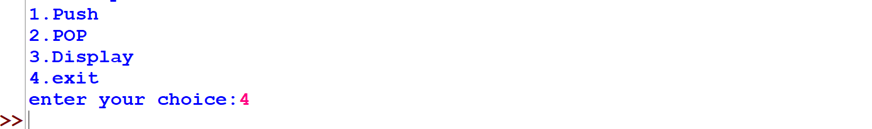
Q21. WAP to implement a stack BooksStack to store book records, each as a dictionary with book_title, author_name, and publication_year. Write the following functions:
• Add a Book: push_book(BooksStack, new_book) to add a book to the stack.
• Remove Top Book: pop_book(BooksStack) to remove and return the top book. Display "Underflow" if empty.
• View Top Book: peep(BooksStack) to display the top book without removing it. Display "None" if empty.
• Count Books: count_books(BooksStack) to return the number of books in the stack.
Input
def push_book(BooksStack, new_book):
BooksStack.append(new_book)

def pop_book(BooksStack):
if BooksStack:
return BooksStack.pop()
else:
print("Underflow")
return None

def peep(BooksStack):
if BooksStack:
return BooksStack[-1]
else:
print("None")
return None

def count_books(BooksStack):
return len(BooksStack)

def display_books(BooksStack):
if BooksStack:
print("Books in Stack:")
for book in BooksStack:
print(book)
else:
print("The stack is empty.")

def main():
BooksStack = []

while True:
print("\n--- BooksStack Operations ---")
print("1. Push a book")
print("2. Pop a book")
print("3. Peep (view top book)")
print("4. Count books")
print("5. Display all books")
print("6. Exit")
choice = int(input("Enter your choice: "))

if choice == 1:
book_title = input("Enter book title: ")
author_name = input("Enter author name: ")
publication_year = int(input("Enter publication year: "))
new_book = {"book_title": book_title, "author_name": author_name, "publication_year": publication_year}
push_book(BooksStack, new_book)
print(f"Book '{book_title}' added to the stack.")
elif choice == 2:
removed_book = pop_book(BooksStack)
if removed_book:
print(f"Removed book: {removed_book}")
elif choice == 3:
top_book = peep(BooksStack)
if top_book:
print(f"Top book: {top_book}")
elif choice == 4:
print(f"Number of books in stack: {count_books(BooksStack)}")
elif choice == 5:
display_books(BooksStack)
elif choice == 6:
print("Exiting program. Goodbye!")
break
else:
print("Invalid choice. Please try again.")

main()
Output
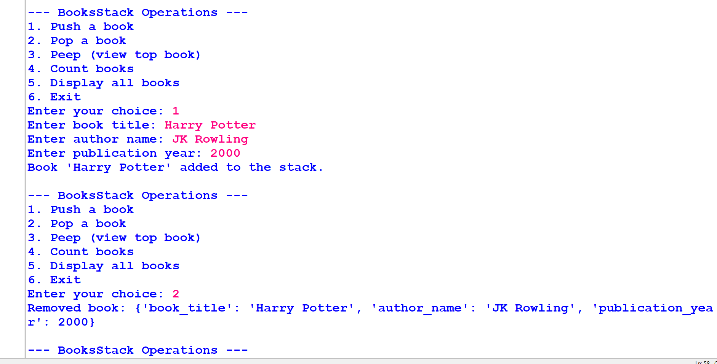
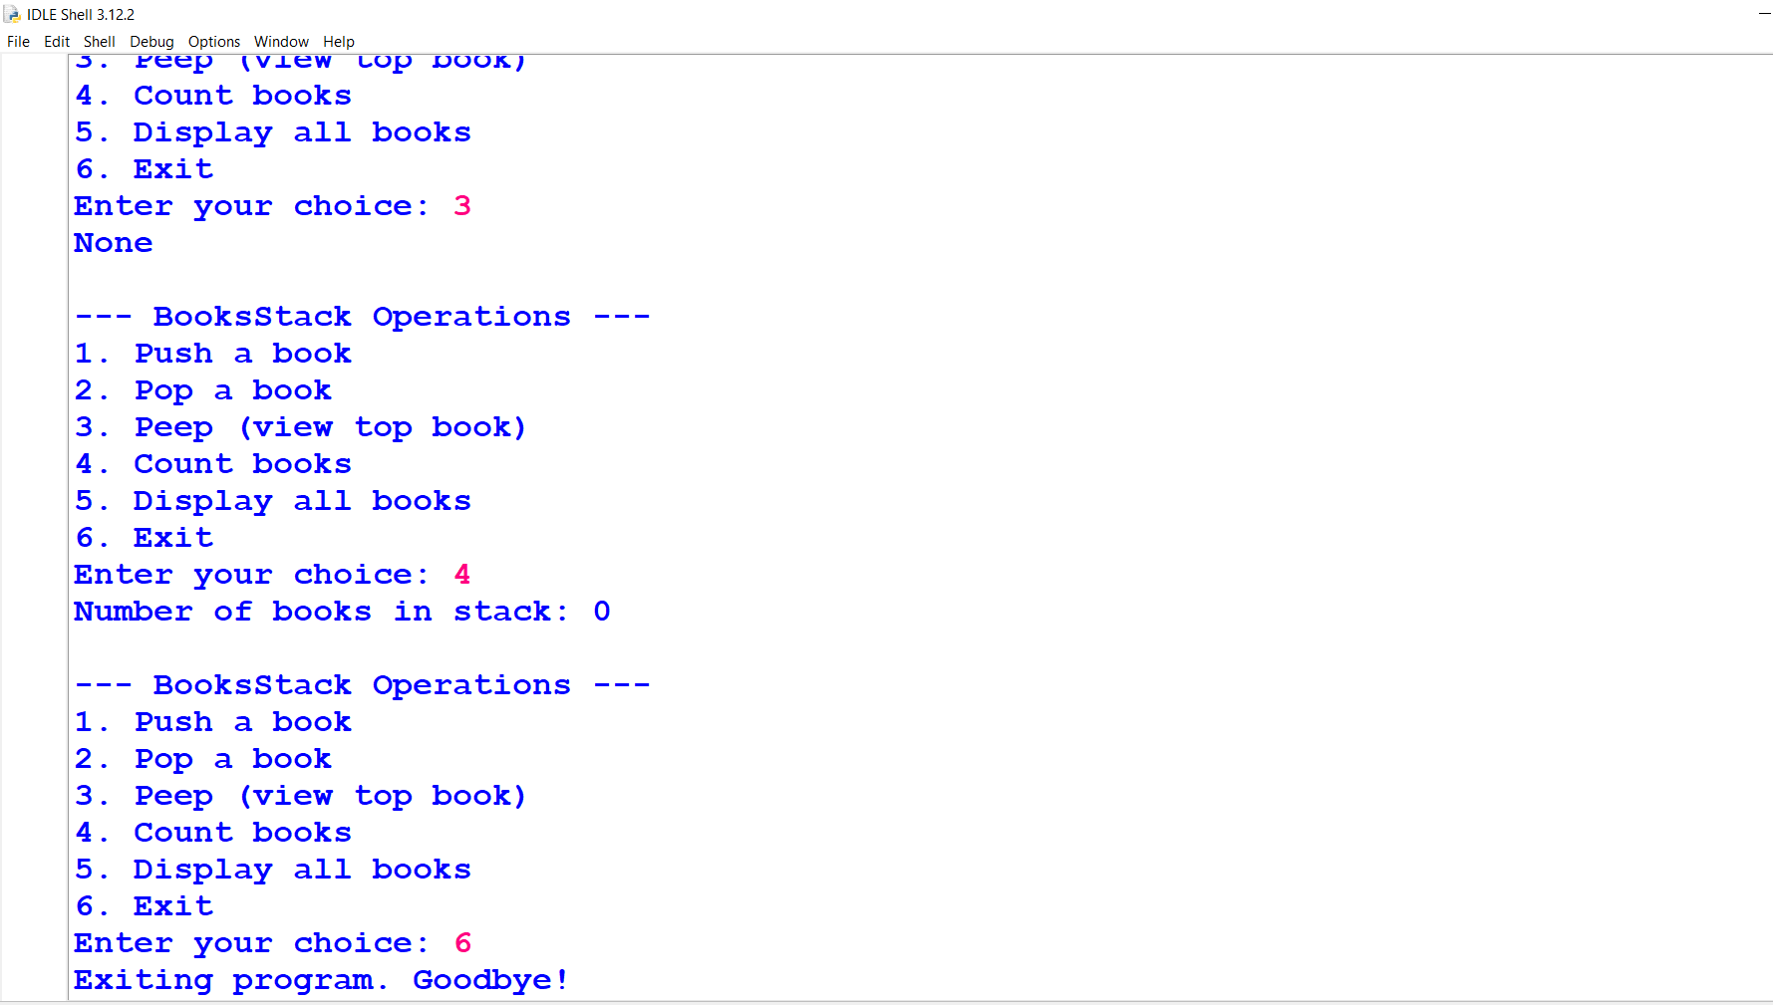
Q22.WAP to perform stack operations on even numbers with the following functionalities:
1. push_even(N) - Push all even numbers from list N into the stack EvenNumbers.
2. pop_even() - Remove and return the top number from the stack. Display "Empty" if the stack is empty. 3. disp_even() - Show all stack elements without deleting. Display "None" if the stack is empty.
The program should allow user input for a list of integers and provide a menu driven interface for operations
Input
EvenNumbers = []

def push_even(N):
"""
Push all even numbers from the list N into the EvenNumbers stack.
"""
for num in N:
if num % 2 == 0:
EvenNumbers.append(num)

def pop_even():
"""
Pop the topmost number from the EvenNumbers stack and return it.
If the stack is empty, display 'Empty'.
"""
if EvenNumbers:
return EvenNumbers.pop()
else:
print("Empty")
return None

def disp_even():
"""
Display all elements of the EvenNumbers stack.
If the stack is empty, display 'None'.
"""
if EvenNumbers:
print("Stack contents:", EvenNumbers)
else:
print("None")

print("Enter a list of integers (e.g., [10, 15, 20, 25, 30]):")
numbers = eval(input())

print("Pushing even numbers from the list:", numbers)
push_even(numbers)

while True:
print("\n--- Stack Operations Menu ---")
print("1. Display all even numbers in the stack")
print("2. Pop the topmost even number")
print("3. Exit")

choice = int(input("Enter your choice: "))

if choice == 1:
print("\nDisplaying the stack:")
disp_even()
elif choice == 2:
print("\nPopping the topmost number:")
print("Popped number:", pop_even())
elif choice == 3:
print("\nExiting the program. Goodbye!")
break
else:
print("\nInvalid choice. Please try again.")
Output
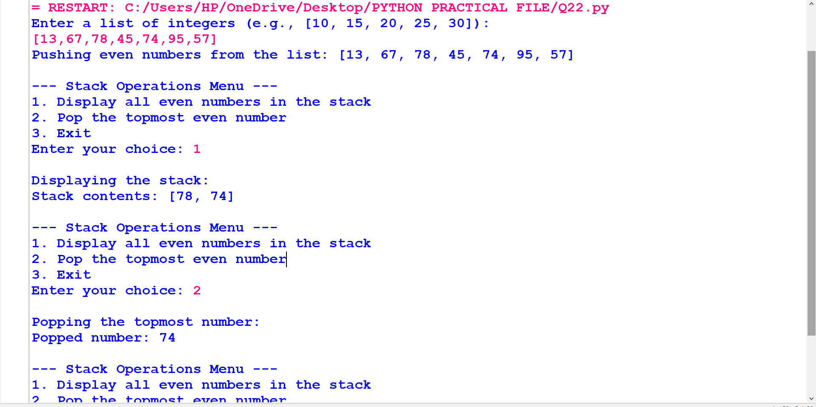
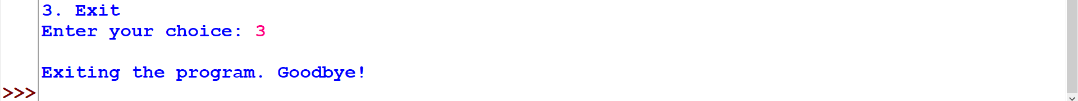
Q23. WAP to create a table Employee using MySQL – Python connectivity to store – Empno, Name, Salary of the employees of the employee of an organisation. Create a menu to provide the following operations on it.
a) Add a new record
b) Display all the records.
c) Update Salary using Empno
d) Delete a specific record.
Input
import mysql.connector
con=mysql.connector.connect(host="localhost",password="123456",user="root",database="employee_data")
cur=con.cursor()
if (con.is_connected()==True):
print("connection established")
cur.execute("create table if not exists emp(empno int(10),name varchar(20), salary int(10))")
print("table-->emp,created successfully")
print("1.add record; 2.display all rec; 3.update salary using empno; 4.delete a record; 5.exit")
while True:
ch=int(input("enter your choice"))
if (ch==1):
while True:
empno=int(input("enter emp number"))
name=input("enter the name of employee: ")
s=int(input("enter the salary of the employee:"))
query="insert into emp values({},'{}',{})".format(empno,name,s)
cur.execute(query)
con.commit()
print("row inserted")
w=input("do you wish to continue adding a record(yes or no)")
if(w=="no"):
break
elif (ch==2):
cur.execute("select * from emp")
data=cur.fetchall()
print("All Records: ")
for i in data:
print(i)
elif (ch==3):
empno=int(input("Enter the empno whose salary is to be updated: "))
salary=int(input("Enter the updated salary: "))
query="update emp set salary={} where empno={}".format(salary,empno)
cur.execute(query)
con.commit()
print("SALARY UPDATED")
elif (ch==4):
empno=int(input("Enter empno whose rec is to be deleted: "))
query="delete from emp where empno={}".format(empno)
cur.execute(query)
con.commit()
print("RECORD DELETED")
elif (ch==5):
print("end of program")
break
else:
print("INVALID CHOICE")
Output
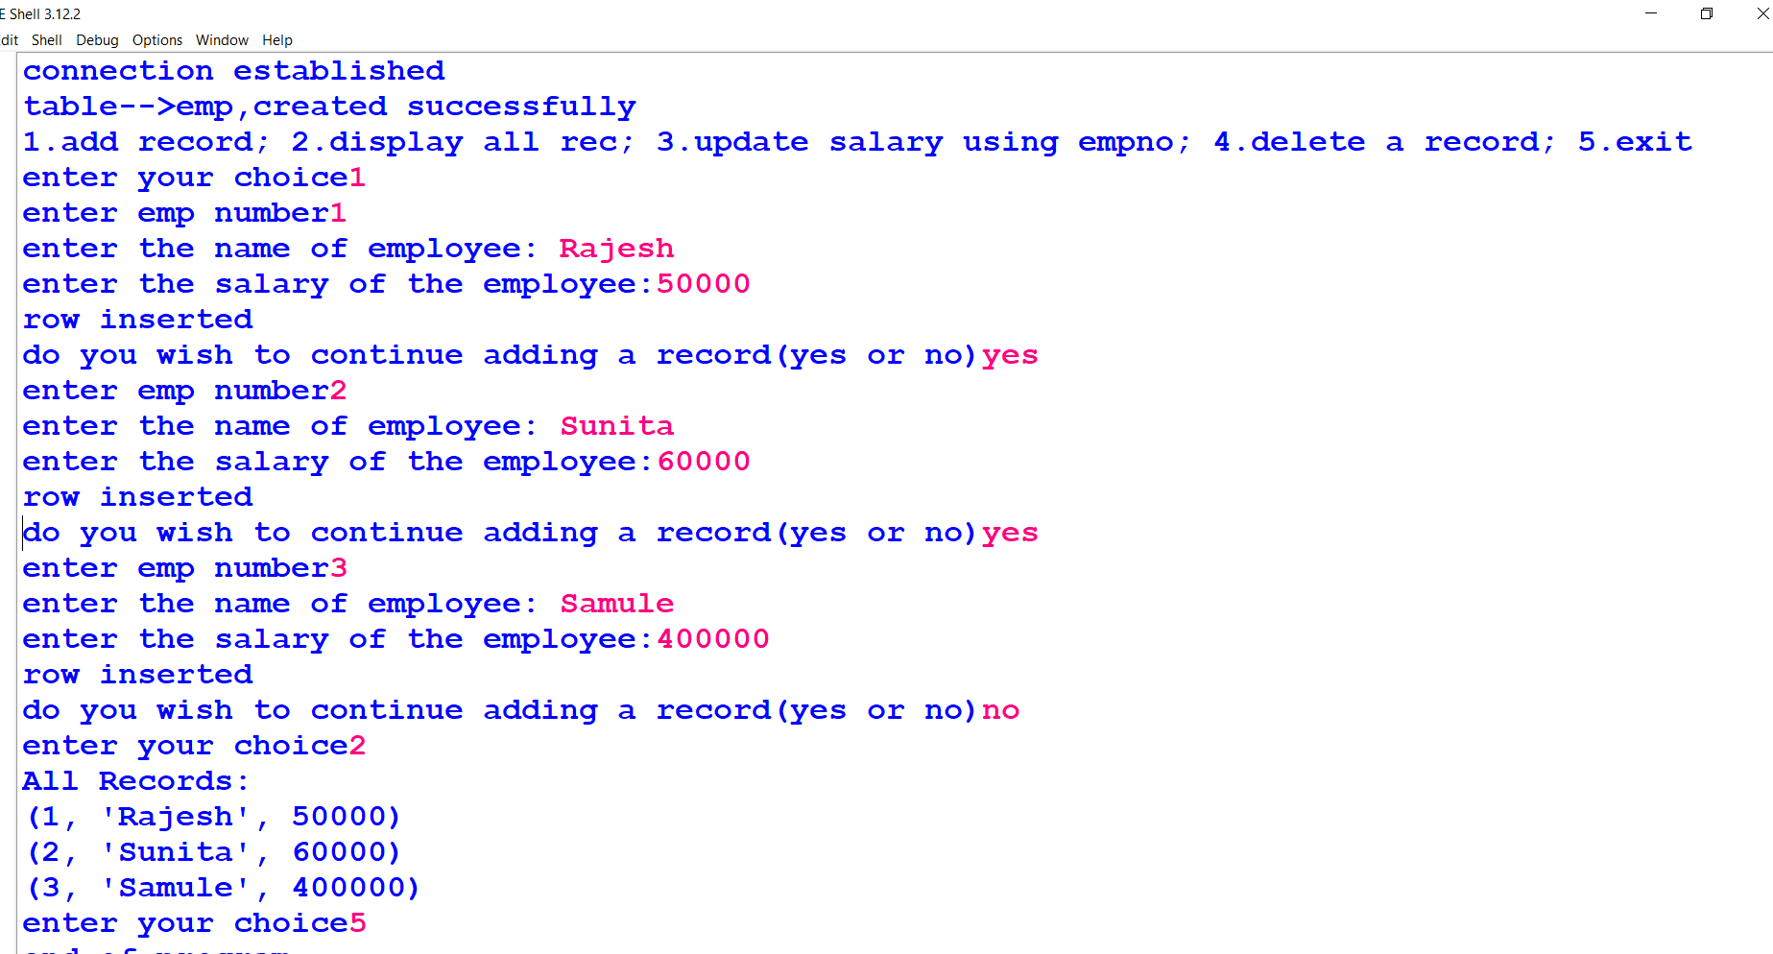
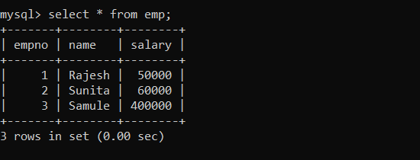
Q24. WAP to implement MySQL – Python connectivity to help maintain the sales record(Phoneno, Date, Item_Quantity and Total Price) and inventory(Item, Cost, Quantity) of a Manufacturing Unit. Create a menu to provide the following operations on it.
a) Add Item.
b) Update Quantity
c) Sale
d) Display Sales Record
Input
import mysql.connector
con=mysql.connector.connect(host="localhost",password="123456",user="root")
cur=con.cursor()
if (con.is_connected()==True):
print("Connection Established")
cur.execute("create database if not exists sales")
cur.execute("use sales")
cur.execute("create table IF NOT EXISTS inventory (item varchar(50),cost int(10),quantity int(10))")
cur.execute("create table IF NOT EXISTS sales (Phone varchar(50),Item_Quan varchar(100),Cost int(10))")
print("1.Add Inventory\n2.Update Inventory\n3.Sale\n4.Sales Record\n5.EXIT")
while True:
ch=int(input("Enter your choice-->"))
if (ch==1):
while True:
iname=input("Enter Item name-->")
cost=int(input("Enter Price per unit-->"))
quan=int(input("Enter Quantity-->"))
query="Insert into inventory values('{}',{},{})".format(iname,cost,quan)

cur.execute(query)
con.commit()# reflected in database
print("ROW INSERTED")
w=input("Do you wish to continue adding a record(yes or no)")
if (w=="no"):
break

elif (ch==2):
cur.execute("select * from inventory")
data=cur.fetchall()
print("All Records-->")
for i in data:
print(i)
i_name=input("Enter item name to be updated-->")
quan=int(input("Enter the fresh quantity->"))
query="update inventory set quantity=quantity+{} where item='{}'".format(quan,i_name)
cur.execute(query)
con.commit()
print("QUANTITY UPDATED")
elif (ch==3):
cur.execute("select * from inventory")
data=cur.fetchall()
print("All Records-->")
for i in data:
print(i)
ch='y'
n_bill=''
bill_amount=0
while True:
n=input("Enter Product")
q=int(input("Enter the quantity"))
q1="Select quantity,cost from inventory where item='{}'".format(n)
cur.execute(q1)
data=cur.fetchall()
p_quan=data[0][0]
p_stock=data[0][1]
if q>p_quan:
print("Stock is not available")
else:
n_bill=n_bill+n
print(n_bill)
query="update inventory set quantity=quantity-{} where item='{}'".format(q,n)
cur.execute(query)
con.commit()
bill_amount=bill_amount+(q*p_stock)
opt=input("Do you want to add more items(y/n)")
if opt=='n' or opt=='N':
break
b_choice=input("Do you wish to bill")
if b_choice=='y':
phone=input("Enter your phone no")
query="Insert into sales values({},'{}',{})".format(phone,n_bill,bill_amount)
cur.execute(query)
con.commit()
print("QUANTITY UPDATED")
elif (ch==4):
cur.execute("select * from sales")
data=cur.fetchall()
print("All Sales Records-->")
for i in data:
print(i)
else:
break
Output
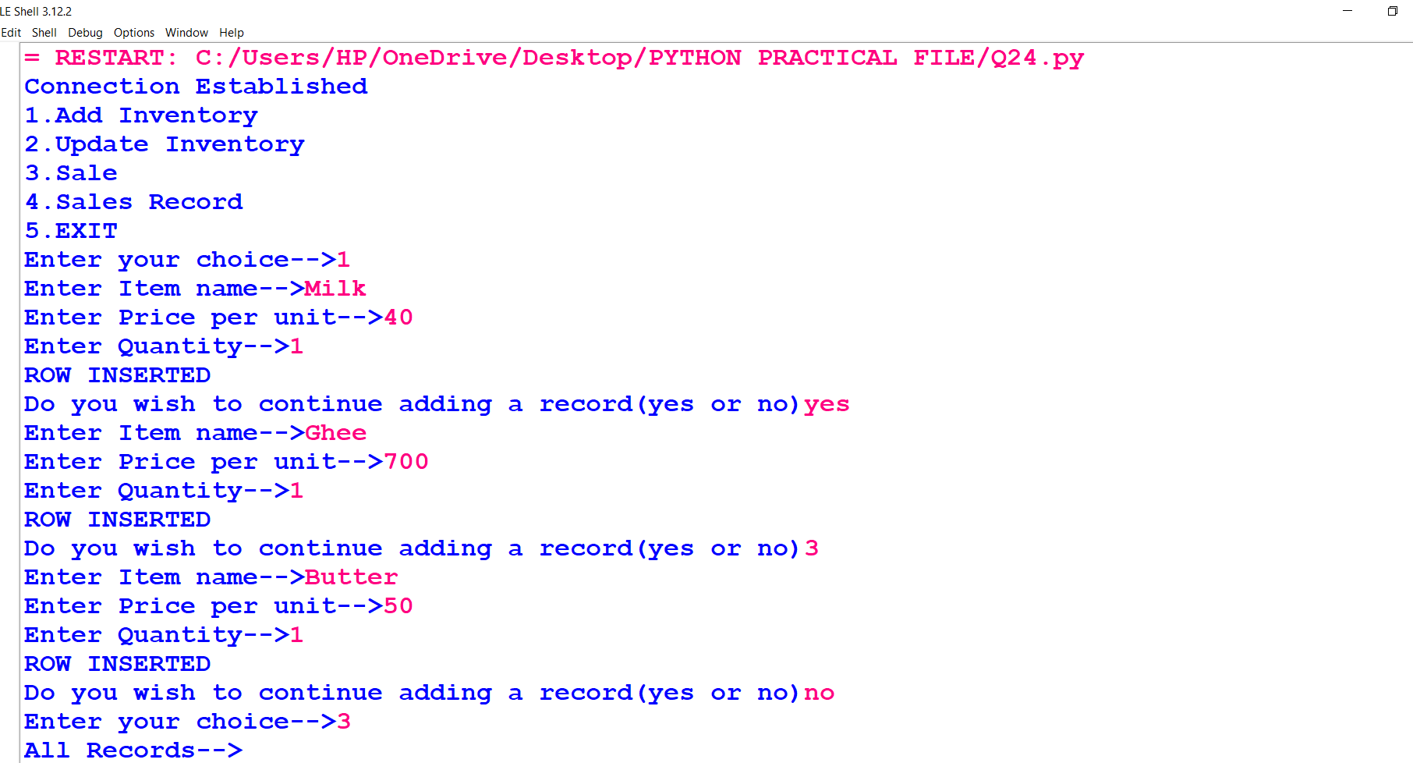
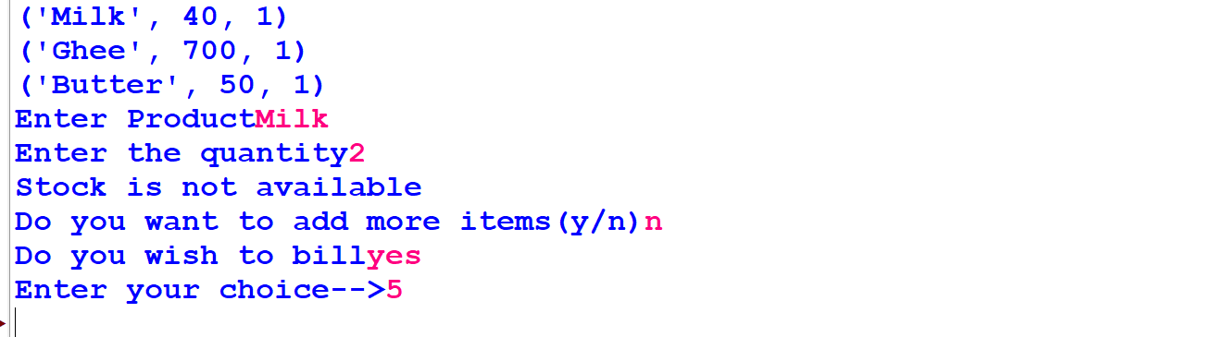
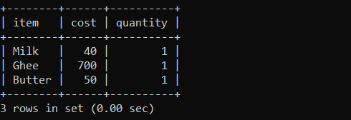
Q25. WAP to help your school create an analysis software for Class XII Board Result
analysis. The program should help to create / maintain the record of students in the
Mysql table Board_Result having the structure as { Admno, Name, Stream,
Percentage}. Create menu to provide the following options to query the record.
a) Add New Student
b) Count of students streamwise.
c) Display the details of the Topper
d) Display highest marks stream wise
e) Display lowest marks stream wise
f) Display records of students having distinction.
g) Display students scoring more than 90%.
Input
import mysql.connector
con=mysql.connector.connect(host="localhost",password="123456",user="root",database="Bresult")
cur=con.cursor()
if (con.is_connected()==True):
print("Connection Established")
cur.execute("create table IF NOT EXISTS Board_Result (Adno varchar(50),Name varchar(30),stream varchar(20),Percentage decimal(5,2))")
print("1.Add New Student\n2.Count of students streamwise.\n3.Select the school topper\n4.Select toppers stream wise\n5.Select lowest marks stream wise\n6.Display records of students having distinction.\n7.Display students scoring more than 90%.")
while True:
ch=int(input("Enter your choice-->"))
if (ch==1):
while True:
adno=input("Admission no-->")
name=input("Name-->")
stream=input("Stream-->")
per=float(input("Percentage-->"))
query="Insert into Board_Result values('{}','{}','{}',{})".format(adno,name,stream,per)
cur.execute(query)
con.commit()
print("ROW INSERTED")
w=input("Do you wish to continue adding a record(Y/N)")
if (w=="n" or w=='N'):
break
elif (ch==2):
cur.execute("select stream,count(*) from Board_Result group by stream")
data=cur.fetchall()
print("Stream Wise Count of Students->")
for i in data:
print(i)
elif (ch==3):
cur.execute("select adno,name,stream,max(percentage) from board_result")
data=cur.fetchall()
print("Details of School Topper->")
for i in data:
print(i)
elif (ch==4):
cur.execute("select max(percentage),stream from Board_result group by stream")
data=cur.fetchall()
print("Stream Wise Toppers->")
for i in data:
print(i)
elif (ch==5):
cur.execute("select min(percentage),stream from Board_result group by stream")
data=cur.fetchall()
print("Stream Wise Lowest Marks->")
for i in data:
print(i)
elif (ch==6):
cur.execute("select * from board_result where percentage>=75")
data=cur.fetchall()
print("ABOVE 75")
for i in data:
print(i)
elif (ch==7):
cur.execute("select * from board_result where percentage>=90")
data=cur.fetchall()
print("ABOVE 90")
for i in data:
print(i)

Output
